| Registration Number:  Date & Session: |
| --- |

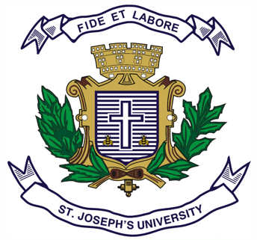

**ST. JOSEPH’S UNIVERSITY, BENGALURU-27**

**M.A. (POLITICAL SCIENCE) – II SEMESTER**

**SEMESTER EXAMINATION: APRIL 2023**

**(Exam conducted in May 2023)**

**PS 8522: POLITICAL THEORY: CONTEMPORARY ISSUES & CONCERNS**

**(For current batch students only)**

**Time: 2 Hours Max Marks-50**

**This question paper contains 1 printed page and two parts**

**PART-A**

**Answer any FOUR out of the following SIX questions in 60-80 words each (4X5= 20 Marks)**

1. Write a brief note on Nationalism.

2. What is Market Socialism?

3. Write a brief note on Conservatism.

4. What is Cultural Nationalism?

5. Write a brief note on Socialism in the 21st Century.

6. What is the Public Sphere?

**PART-B**

**Answer any THREE out of the following FIVE questions in 300-`400 words each (3X10= 30 Marks)**

7. Discuss Benedict Anderson’s idea of an ‘Imagined Community’.

8. Compare and Contrast between Modernity and Post-modernity.

9. Bring out Michael Sandel’s arguments pertaining to ‘Justice’.

10. Explain the arguments pertaining to Civil Society as put forth by Sudipta Kaviraj and Sunil Khilnani.

11. Discuss Partha Chatterjee’s critique of Benedict Anderson’s Thesis on Nationalism.

PS 8522-A-2023