

Registration Number:

Date & session:

Registration Number:

Date & session:

**ST.JOSEPH’S UNIVERSITY, BENGALURU -27**

**MSc Zoology – I SEMESTER**

**SEMESTER EXAMINATION: OCTOBER 2023**

**(Examination conducted in November /December 2023)**

**ZO7122: Biology and Diversity of Non Chordates**

**(For current batch students only)**

**Time: 2 Hours Max Marks: 50**

**This paper contains TWO printed pages and FOUR parts**

**PART- A**

**Answer ALL the questions. (5 X 1 = 5)**

1. What is the significance of water canal system in sponges?
2. Differentiate between class Hydrozoa and Anthozoa.
3. Why nematodes are known as roundworms?
4. Stone canal is found in phylum ______________
5. Name the parts I, II and III

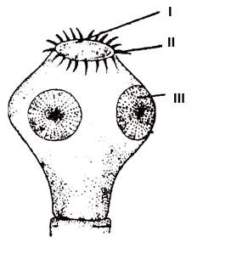

**PART – B**

**Answer the following questions (5 x 2 = 10)**

1. Differentiate between paratype and holotype.
2. Name the different types of cells which are responsible for the formation of different types of spicules.
3. Why *Peripatus* is the connecting link between Annelida and Arthropoda?
4. Explain Axopodia structure with a neat labelled diagram
5. Write a note on Chlorocruorin

**PART – C**

**Answer any THREE of the following questions (3 x 5 = 15)**

1. Give the general characters and outline classification of phylum Platyhelminthes with its classes.
2. Write a note on the phylogenetic position of the phylum Onychophora.
3. Arthropods are adopted to live in various habitat. Explain any two structures which help in excretion among arthropods with neat labeled diagram.
4. What is parthenogenesis? Describe the types with examples.
5. Write a note on nervous system of earthworm.

**PART – D**

**Answer any TWO of the following questions (2 x 10 = 20)**

1. Give an account on the criteria employed in classification of animals on the basis of symmetry, germ layer and coelomic condition.
2. Hormones play an important role in the development of insects, substantiate the statement with illustration
3. What is coral reef? What is the ecological significance? Explain its types and formation