
Register Number:
DATE:

ST.JOSEPH’S COLLEGE (AUTONOMOUS), BANGALORE-27
B.Sc ELECTRONICS – IV SEMESTER
SEMESTER EXAMINATION- APRIL 2020
EL 418- VERILOG HDL

Time: 1 ½ hrs Maximum marks: 35
This question paper has TWO printed pages and THREE parts.
PART – A
ANSWER ANY THREE OF THE FOLLOWING 3X5=15 Marks
1. a) Define module? Explain four levels of abstraction.

2. a) Give one example for Binary, Unary and Ternary operators.
b) Explain Nets and registers data types. (3+2)

3. a) Give any three characteristics of continuous assignments .
b) With example explain the following operators.
i) === ii) ** (3+2)

4. a) Explain the following with example.
i) Regular assignment delay
ii) Implicit continuous assignment delay
iii) Net declaration delay (2+2+1)

5. a) Give any three characteristics of Functions.
b) With example explain declaration of Task. (3+2)

PART – B
ANSWER ANY THREE OF THE FOLLOWING 3x6=18 Marks
6. Write design and test module to implement full subtractor using gate level modeling.

7. Write design and test module to implement 4x1 De-multiplexer using gate level modeling.

8 Write design and test module to implement S R flip-flop using behavioral modeling.

9. Writ design and test module for given circuit using behavioral modeling.
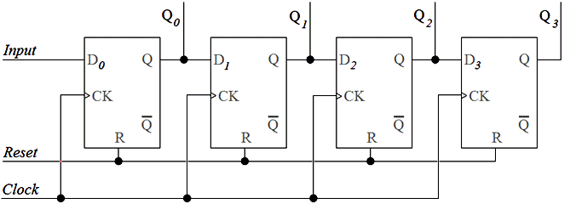

10. Write a design and test module to realize a 4-bit ripple carry counter using behavioural
modeling.

PART – C
ANSWER ANY TWO OF THE FOLLOWING 2x1=02 Marks
11. Write the output for the given code
in1 = 4’b101x;
in2 = 4’b1010;
sum = in1+in2;

12. What is the difference between a wire and a register?
13. Mention looping statements available in verilog.

14. What are the two variations of case statement?
*************************************************************************************************************

