
Register Number:
DATE:

ST.JOSEPH’S COLLEGE (AUTONOMOUS), BANGALORE-27
B.Sc ELECTRONICS – IV SEMESTER
SEMESTER EXAMINATION- APRIL 2020
EL 418- VERILOG HDL

Time: 1 ½ hrs Maximum marks: 35
This question paper has TWO printed pages and THREE parts.
PART – A
ANSWER ANY THREE OF THE FOLLOWING 3X5=15 Marks
1. With example explain design methodologies.

2. a) Declare the following in verilog
i) An 8-bit vector net called bus A
ii) Two dimensional array of integers
iii) memory with 1k 8-bit words(bytes)
b) Explain $display, $monitor system tasks. (3+2)

3. a) With example explain Blocking assignment statements.
b) With example explain always statement. (3+2)

4. a) With example explain Blocking and Non-blocking assignment statements.

5. a) Explain the general syntax of for loop statement.
b) Give any three differences between Task and Functions. (2+3)

PART – B
ANSWER ANY THREE OF THE FOLLOWING 3x6=18 Marks
6. Write a design and test module to implement 4-bit ripple carry adder using gate level
modeling.

7. Write a design and test module for given circuit diagram using gate level modeling.
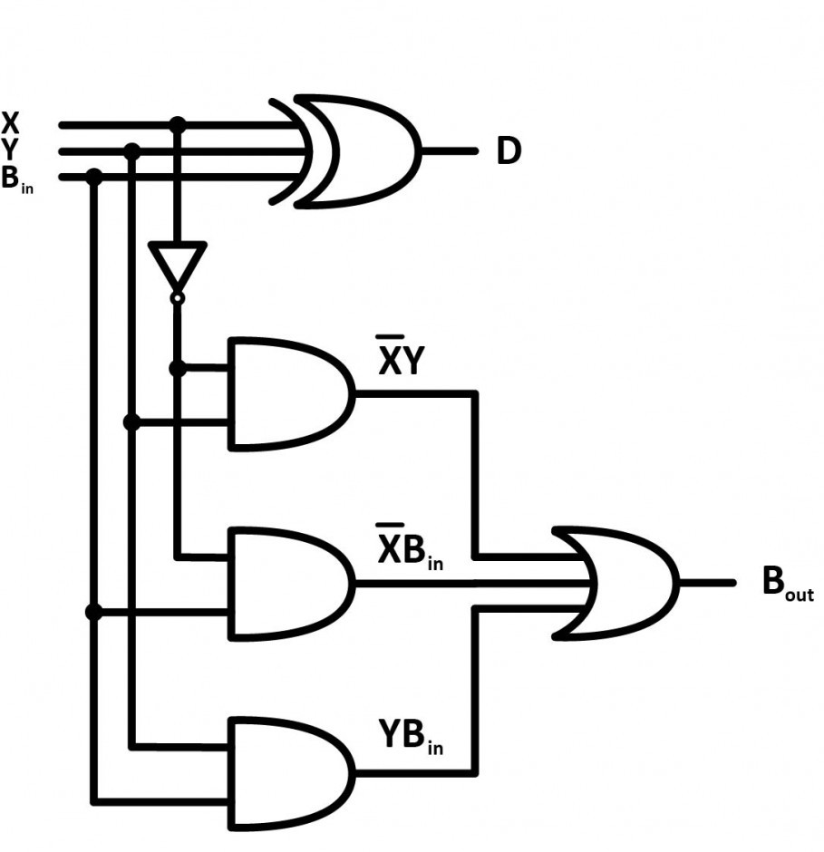.

8 Write a design and test module to implement J K flip-flop using behavioral modeling.

9. Write a design and test module to implement 4x1 multiplexer using behavioral modeling

10. a) Write a design and test module for 4-bit ripple carry counter using T-flip-flops.

PART – C
ANSWER ANY TWO OF THE FOLLOWING 2x1=02 Marks
11. Declare a memory MEM containing 256 words of 64 bit each.

12. What is the difference between logical equality and case equality operators?
13. Name the statement that executes only one statement among many statements, if the
condition is true.

14. What is the value of Y
A = 1’b1, B = 2’b00, C = 2’b10
Y = { A, B[0], C[1] };
*************************************************************************************************************

