 |  |  | 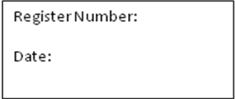
ST. JOSEPH’S COLLEGE (AUTONOMOUS), BANGALORE-27
M.S.W. - IV SEMESTER
SEMESTER EXAMINATION: APRIL 2018
SWDE 0515 – Urban Community Development
Time- 2 ½ Hours |  |  |  | Max Marks - 70
This paper contains ONE printed page

PART - A
Answer any FIVE of the following questions: 10 x 5 = 50 Marks
- What are the characteristics and types of cities?
- Describe the various theories of urbanization.
- Explain the objectives and principles of Urban Community Development.
- Write a note on structure and functions of local urban administrative bodies.
- Write a note the problem of Urban pollution.
- Mention the main features of various Urban Legislations.
PART - B
Answer any ONE of the following questions: 1X 20 = 20 Marks
- Explain various programmes and policies of urban Community Development.
- Highlight the problem of Urban Slums in Indian cities and measures to overcome urban poor issues.

