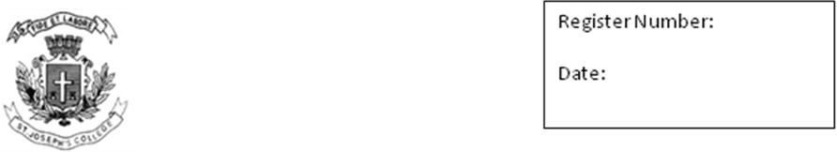
ST. JOSEPH’S COLLEGE (AUTONOMOUS), BANGALORE-27
M.S.W. I V SEMESTER
SEMESTER EXAMINATION: APRIL 2018
SWDE0815- Disaster Management
Time- 2 1/2 Hrs |  |  | Max Marks-70
This paper contains ONE printed page and TWOparts
PART I
Answer any FIVE of the following: 5 X 10 = 50 Marks
- Explain the different types of disasters with examples
- Man Made disasters are more dangerous than Natural disasters, Do you agree explain with examples.
- Explain the physical, social, economical and psychological impacts of Tsunami
- Explain the role of social workers after Tsunami and cyclone.
- Explain the disaster management techniques and its phases
- What are the responsibilities of community, Panchayati raj, Urban local bodies, states and centre in times of disasters?
PART II
Answer any ONE of the following: 1 X 20 = 20 Marks
- Illustrate the role of National and international agencies working towards disaster management and relief.
- Explain with examples the role of social workers in resource mobilization, working with other professionals, working with the Government and voluntary organization.

