ST. JOSEPH’S COLLEGE (AUTONOMOUS), BANGALORE-27
MSW - IV SEMESTER
SEMESTER EXAMINATION: APRIL 2018
SWDOE : 0715 – Human Resource Management
Time- 2 ½ Hours |  |  | Max Marks-70
This paper contains ONE printed page and TWO parts.
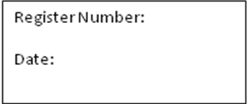

PART : ONE
Answer any FIVE of the following: 5 x 10 = 50 Marks
- Define Human Resource Management and explain the importance of Human Resource Planning.
- Describe the various elements related to the concept of Job Analysis.
- Describe the concept and principles of Labour Welfare.
- Enumerate the various aspects of wage administration.
- Highlight on the role of an industrial social worker.
- What are the main features of the Workmen’s Compensation Act of 1923?
PART: TWO

Answer any ONE of the following: 1 x 20 = 20 Marks
- What are its main functions of Human Resource Management? Describe competencies of an HR Manager.
- Mention the main provisions of Factories Act of 1948 and elaborate it suitable examples.

