

Register Number:

DATE:10-4-2017

**ST. JOSEPH’S COLLEGE (AUTONOMOUS), BENGALURU-27**

**M.Sc. BIG DATA ANALYTICS – II SEMESTER**

**SEMESTER EXAMINATION: APRIL 2017**

**BDA 2116: Foundation of Data Science**

**Time 2.5 Hours Maximum Marks 70**

**This Question Paper Contains TWO Printed Paper And ONE Part**

**AnswerAny Seven questions 7 x10 = 70**

1. Using Dijkstra's Algorithm find the shortest path

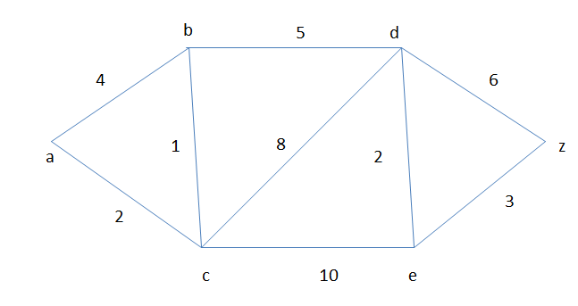

1. Using Kruskal's Algorithm find the Minimum Spanning Tree

BDA-A-17

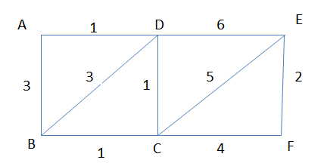

1. a) Explain High dimensional space graphically with a suitable example.

b) Let x be a nonnegative random variable. Then for a > 0, Prob(x ≥ a) ≤ (E(x) /a)

(5+5)

1. State and prove law of large number.
2. a) Explain Jaccard similarity with a suitable example.

b) Explain Erdo and Renyi’sG(n,p) model on random graph. (5+5)

1. Find SVD , A= $\left[\begin{matrix}5 & 5 \\ -1 & 7\end{matrix}\right]$
2. What do you mean by reflection principle? Explain with suitable example.
3. a) What is stream model ? How is it different from DBMS ?

b) Give three different applications of stream model . (5+5)

1. Explain the frequency moment of data stream.