

Date:12-03-2022

Registration number:

**ST. JOSEPH’S COLLEGE (AUTONOMOUS), BENGALURU-27**

**MA JOURNALISM AND MASS COMMUNICATION - III SEMESTER**

SEMESTER EXAMINATION: OCTOBER 2021

(Examination conducted in March 2022)

**MC 9420 – Data Journalism**

**Time- 2 ½ hrs Max Marks-70**

This question paper contains **THREE** printed pages and **THREE** parts:

1. **Write short notes on any FOUR in 150 words each: (4×5 = 20)**
2. Afghan war logs
3. Data mining
4. Cross-border collaboration
5. Data Point in *The Hindu*
6. Wikileaks

**II. Answer any THREE in 300-400 words each: (3×10 = 30)**6. Explain the steps to construct a journalistic narrative using either quantitative or qualitative sources.

1. What are the relevance and significance of repurposing content? Describe the ways in which a media organisation repurposes content through data analytics.
2. Explain the status of data journalism in the Indian context.
3. Explain how pivot tables help you sort and refine datasets.   
     
   **III. Write 200-250 word stories each based on any TWO questions: (2×10 = 20)**
4. The chart shows the rupee’s US dollar exchange rate between 1 January 2010 and 1 January 2022. Write a news story about the rupee breaching 76-to-a-dollar mark on 16 December 2021, an 18-month low. (Refer to the image in the next page)  
   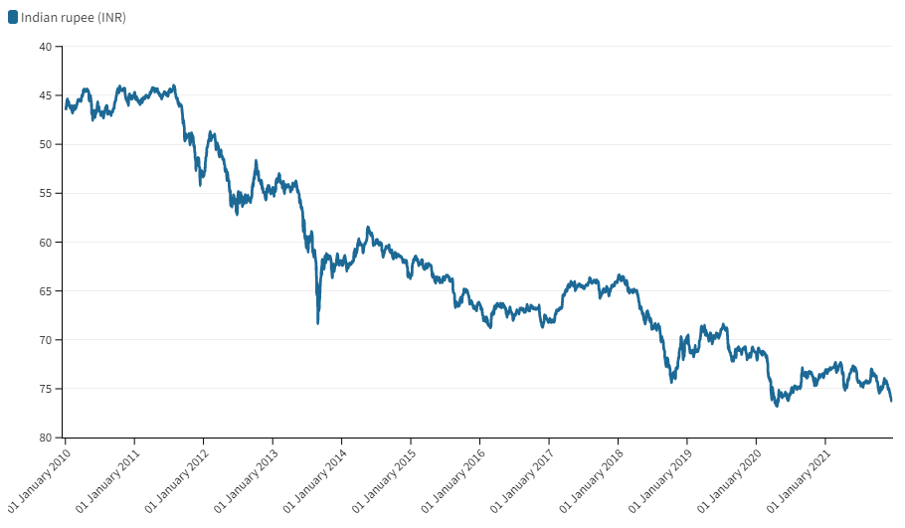
5. According to a Pew Research Centre survey, in India, “substantial minorities would not accept followers of other religions as neighbours.” Based on the following, write a story on religion and tolerance in the country.  
     
   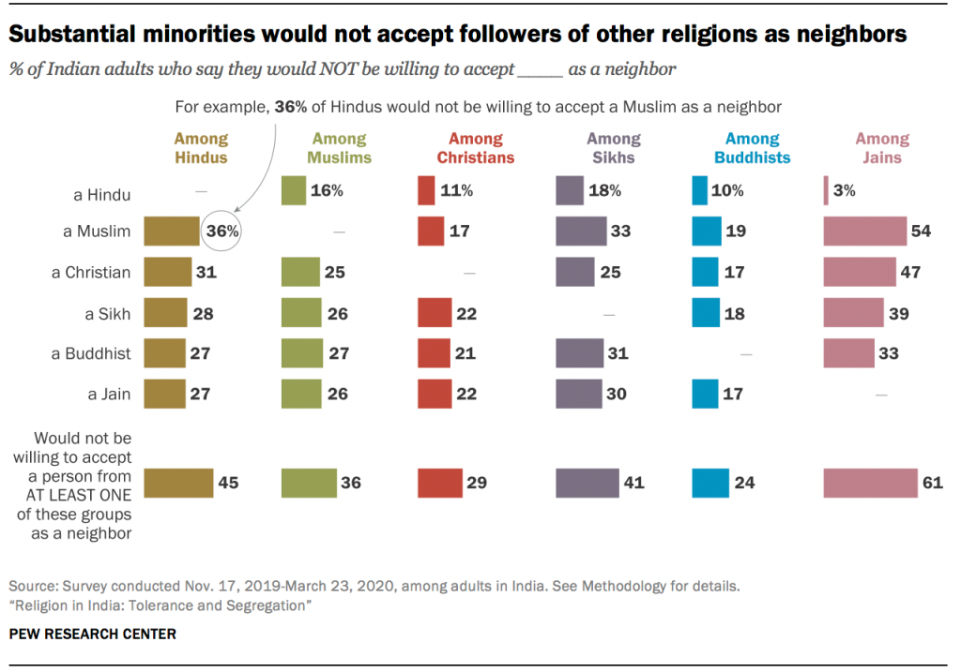
6. Based on the following graph, explain the significance of data journalism in media today.  
     
   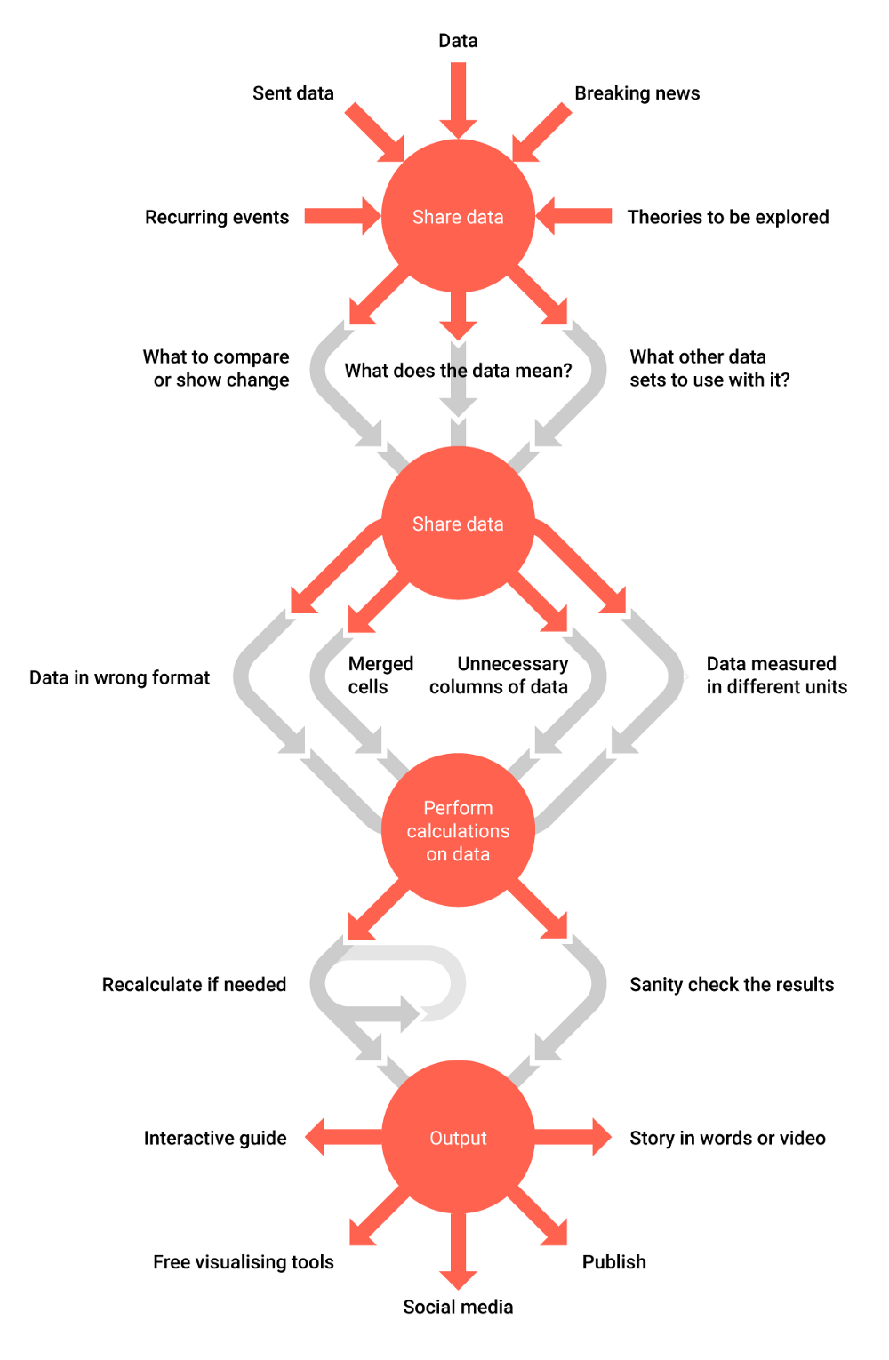

MC 9420_B_2021

******